Sprint Backlog
INB201
Tasks list
Associate with
Name
State
Remaining time
Responsible
Description
Notes
Creator
ID
Urgent task
User Interface: Reports/Forms
Done
0.0
Saud Al jehani
Draft of Reports and Forms

Joseph Salmond
8
Urgent task
Documentation/Administration
Done
0.0
Joseph Salmond
MOAR documentation/Administration

Joseph Salmond
10
Urgent task
Database Documentation
Done
0.0
Abdullah Alghunaim
Graphical representation of Database Relationships/Schema

Joseph Salmond
6
Urgent task
User Interface: Forms/Reports
Done
0.0
Syed Ali
Draft of Forms and Reports

Joseph Salmond
9
Urgent task
Database DeployDraft SQL
Done
0.0
Kaan Osmanagaoglu
deploy database Prototype to Microsoft SQL server

Joseph Salmond
7
Scrum report generated with iceScrum
Page 1 /
4
Thursday 27 March 2014
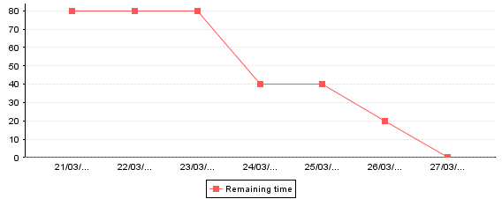
INB201
Sprint burndown chart
Remaining time
Days
Scrum report generated with iceScrum
Page 2 /
4
Thursday 27 March 2014
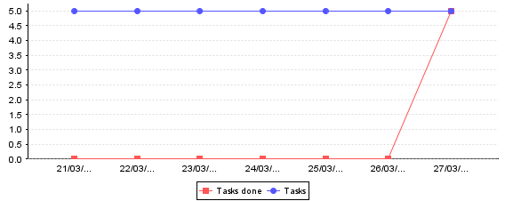
INB201
Sprint burnup chart (tasks)
Tasks
Days
Scrum report generated with iceScrum
Page 3 /
4
Thursday 27 March 2014
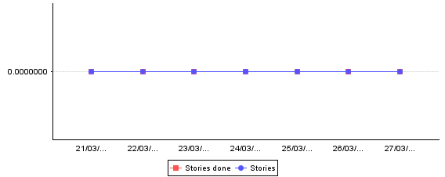
INB201
Sprint burnup chart (stories)
Stories
Days
Scrum report generated with iceScrum
Page 4 /
4
Thursday 27 March 2014

